**Author: Akash Rathod**

**GRIP The Sparks Foundation**

**Role: Data Science & Business Analytics intern**

**Duration: February 2023 (Batch)**

**Task 3: Exploratory Data Analysis - Retail**

(Level Beginner)

**Problem Statement:**

Perform ‘Exploratory Data Analysis’ on the provided dataset ‘SampleSuperstore.csv’. You are the business owner of the retail firm and want to see how your company is performing. You are interested in finding out the weak areas where you can work to make more profit. What all business problems you can derive by looking into the data? You can choose any of the tool of your choice (Python/R/Tableau/PowerBI/Excel)

1. **The Dashboard is Created using PowerBI.**

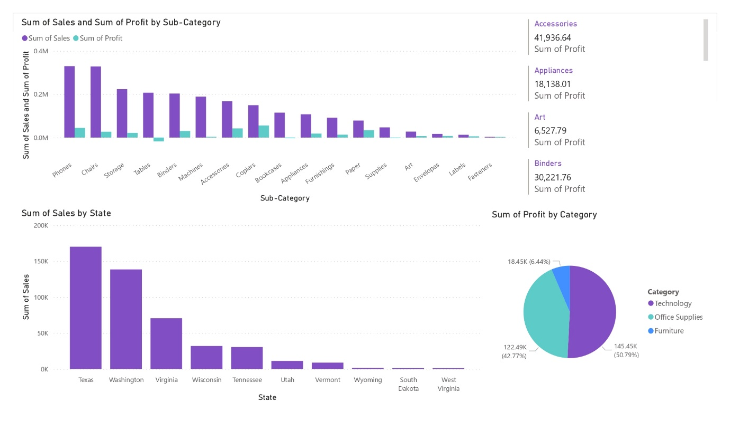

1. **It is observed from the dashboard that the Accessories category has a good profit to sales ratio and is performing good in the market.**

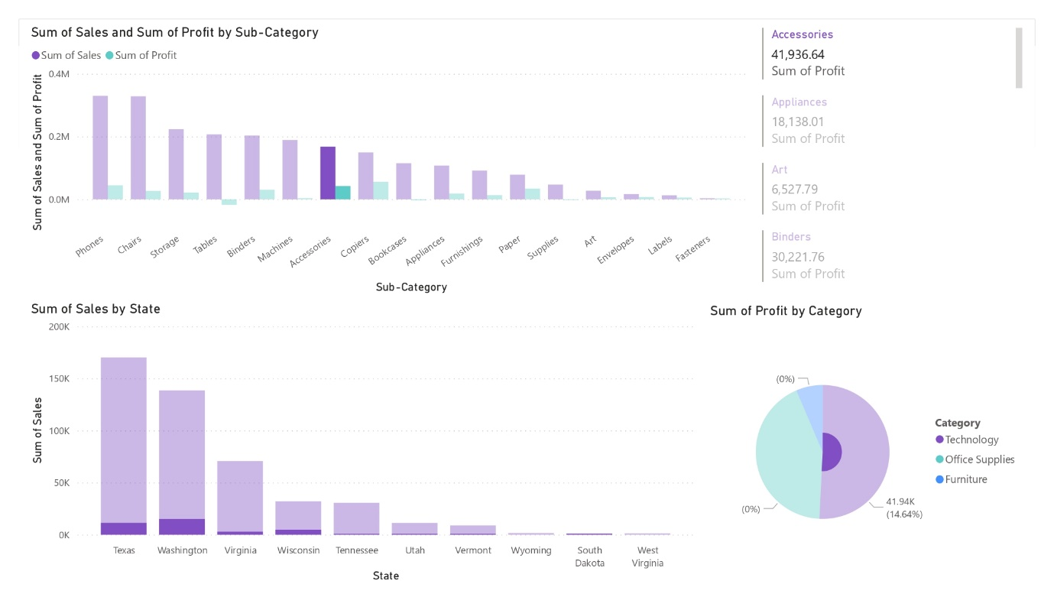

1. **The Highest Sum of Profits performing categories are Phones and Chairs.**

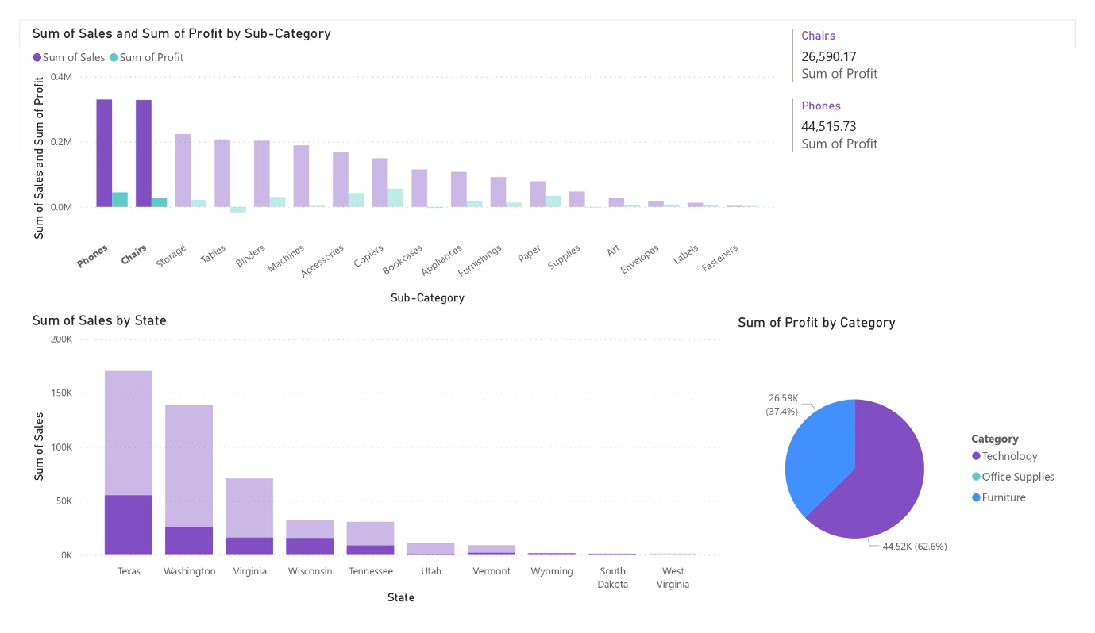

1. **As a business manager, try to find out the weak areas where you can work to make more profit?**

It is being observed that the “Technology” and “Office-Supplies” Sub-Category have high profit whereas “Furniture” has less profit.

